Frozen Kingdom | Class: Oaks  Term: Spring
Driver Subject: Geography  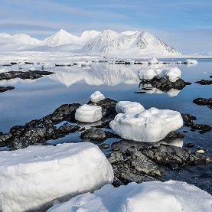  This project teaches children about the characteristics and features of polar regions, including the North and South Poles, and includes a detailed exploration of the environmental factors that shape and influence them. | Science  Habitats, Evolution and Inheritance  Electrical Circuits and Components    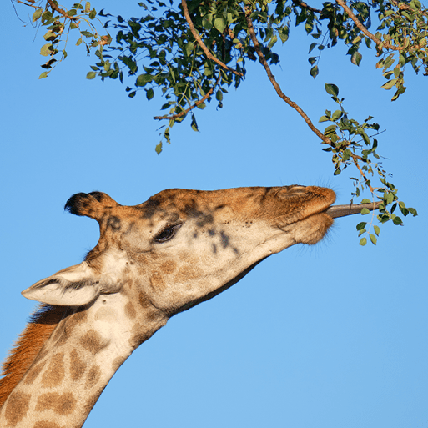
English
Non-Fiction The Origin of Species – Non-Chronological Report
Non-Fiction Emperor Penguins - Non-Chronological Report
Non-Fiction – Scott of the Antarctic - Diary
Narrative - Ghost Story – Fantasy Story
Narrative – Greta - Speech
Maths
Multiplication and Division B
Fractions B
Decimals and Percentages
Perimeter and Area
Statistics
Geography
Our Changing World Part 1 - Features of Earth including the Arctic and Antarctic Circles; Time zones, Latitude and longitude; Map scale; Grid references, contours and symbols; Climate change, extreme weather and people; Worldwide trade; Natural resource management; Road safety; Fieldwork; Settlement patterns; Local enquiry
Religious Education
How do questions about Brahman and Atman I’ - influence the way a human lives?
What is the great significance of eucharist for Christians?
Art and Design  Environmental Artists- This project teaches children about the genre of environmental art. They study how artists create artwork that addresses social and political issues related to the natural and urban environment.  Inuit - This project teaches children about the Inuit way of life, including some of their cultural and artistic traditions. | D&T  Engineers  This project teaches children about remarkable engineers and significant bridges, learning to identify features, such as beams, arches and trusses. They complete a bridge-building engineering challenge to create a bridge prototype.
Computing  E-Safety  Data and information – introduction to spreadsheets  PowerPoint presentation - Cornerstones topic | Music  Balinese gamelan - Gamelan from Bali, interlocking rhythms, vocal chant, structure  Ame sau vala tara bal – Indian music, bhairavi raga, chaal rhythm, Indian musical instruments, Indian musical styles comparison (bhangra, Bollywood, Indian classical)
PSHE
Worry
British Values
French  The date  Clothes | P. E  Gym  Dance  Football  Tennis

These activities are for you to do at home. You can do all of them or choose the ones that you find most interesting.

What will you choose to do?

1. Polar animals include polar bears, emperor penguins, Siberian salamanders, Greenland sharks, emerald rockcod, walrus and Arctic terns. Compare two of these species, recording where they are found, their habitats and what they eat.

2. Draw a detailed diagram of the two species that you compared. Add labels to identify their key features and adaptations

3. Throughout time, there have been many explorations of the polar regions. Use the internet and other source materials to find out about polar explorers and their discoveries. Create a timeline to show significant polar explorations that took place between 1770 and 1920.

4. Choose one polar explorer that you find inspiring. Find out as much as you can about them and write a short biography about their life, motives for exploration, achievements and discoveries.

5. Use online and other historical resources to find out what happened to the RMS Titanic. Write an account to explain what happened, including how polar features were instrumental in its downfall.

6. Many people are concerned about the impact of climate change on the polar regions. Gather evidence to find the answers to the following questions. • What is global warming? • What is climate change? • What are four causes of global warming? • What is the impact of climate change on the planet? • What is the impact of climate change on wildlife? • What are your thoughts and feelings about climate change?
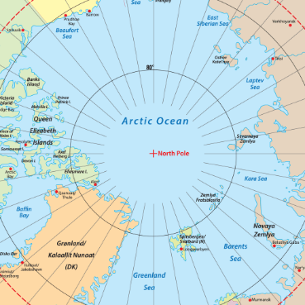
Useful websites
Britannica Kids Antarctica
Britannica Kids Arctic Regions
Met Office Climate zones
National Geographic Kids What is climate change?
DKfindout! – Polar Exploration Famous Polar Explorers
Britannica Kids Polar Exploration
National Geographic Kids – Titanic Facts

