Acers News!
With the end of November approaching, school life becomes very busy with lots of exciting activities coming up! Already, we have had a jam-packed couple of weeks and Acers have really focused on their learning.
In writing, we have been looking at the picture book “Float”. We have really enjoyed creating our own narrative for this and used drama to act out some of the parts. During this unit, we had the opportunity for an exciting “experience day”. The children needed to describe how it felt to be all cozy and warm with a hot chocolate after being outside in the cold. We had the best lesson in our dressing gowns, fluffy socks and blankets drinking hot chocolate!
This week, the children have been completing assessments for maths, reading, spelling and grammar. I have been so proud of every single one of them for the effort they have made. They have been so resilient and respectful throughout. You may have some tired superstars tonight!
In RE, our question is: How does a Muslim show their submission and obedience to Allah? We shown great curiosity with this unit and the children really enjoyed making Muslim prayer position out of Play-Doh.
In guided reading, we will continue to read BFG. If your child would like to bring the book to support their sessions, they are more than welcome to do so.
A reminder that PE days are on Tuesdays and Thursdays. Tuesday’s session with Mr Woodward is dance (indoor) and my session on Thursday is Netball (outdoor weather permitting). Please remember that children need to wear black/dark blue leggings or joggers, their while PE t-shirt and their school jumper. They may bring hoodies/jackets as additional layers.
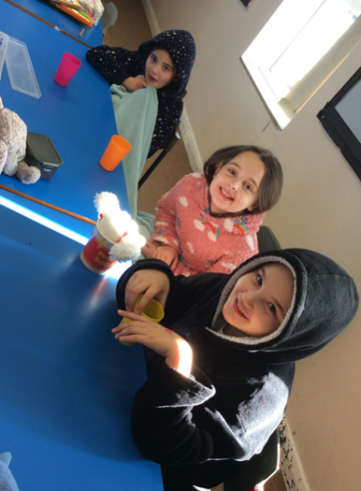
Thank you for a lovely couple of weeks. Prepare yourself the Christmas chaos!
Mrs Colville, Mrs Bowering and Mrs Garry


