Class: Acers | Term: Autumn 2025
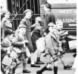  Driver Subject: History  A siren sounds, a building crumbles, a Spitfire zooms overhead. Take cover. It’s 1939 and Britain is at war. Deep down in the Anderson shelter, learn why nations are fighting and why child evacuees must make the long journey from their homes and families into unknown territory. Read the diary of Anne Frank, written whilst hiding from the terrifying stormtroopers in a secret annexe, and try to empathise with her hopes and fears. Make do and mend. Cook up a family meal from meagre rations. Delve deep into a bygone era, when loose lips sunk ships. And, as peace is declared, let’s get ready to celebrate. Mr Churchill says ‘It’s an unconditional surrender.’ | Science Projects  Sound    Habitats and Evolution and Inheritance  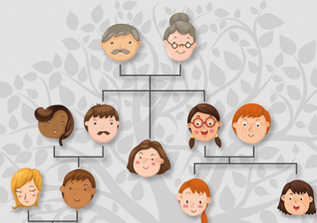
English
Narrative Writing Story –The BFG.
Non-Fiction – Newspaper report – The Creature
Maths
Y4: Place Value, addition and subtraction, measurement, multiplication and division
Y5: Place Value, addition and subtraction, multiplication and division, fractions

Religious Education
How does the story of Rama and Sita inspire Hindus to follow their Dharma?
How does a Muslim show their submission and obedience to Allah?

Art and Design  Distortion and abstraction  Bees, beetles and butterflies. | D&T  Make do and mend.
Computing  Powerpoint Presentation  Programming | French  Phonics
Music  This little light of mine - Gospel | Extras:  PE days: Tuesday and Thursday  A child’s war glossary:  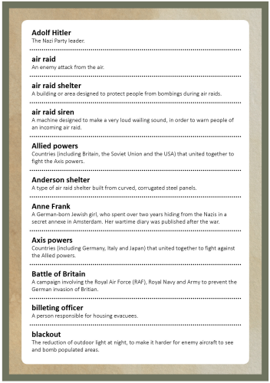
PSHE
Cycle Safety
Healthy living
Coming home on time
PE and Games
Tag Rugby Outdoor adventurous activities
Netball Dance

These activities are for you to do at home with an adult. You can do all of them or choose the ones that you find most interesting.

- Research World War II and create a mind map to organise and record your findings under headings of your choice, then use your mind map to write a non-chronological report. Include a title, an opening paragraph, subheadings, detailed and interesting facts, precise topic vocabulary and images with captions.

- Create an evacuee label for your friend.

- Answer the question, can we block sound? by setting up your own investigations.

- Go outside and find an inset to draw in an observational drawing. Then, create a collage with your drawing.

- Find some clothes that either have holes in them or that you don’t like any more. Design a way to make them better or mend them.
6. During the war, people kept themselves safe from bombing attacks by using gas masks, Anderson shelters and Morrison shelters. Use a range of sources to find out about these safety measures and complete a table to record your findings. Include descriptions and how they protected people.

Useful websites

World War Two: An Overview - World War Two and the Holocaust - KS3 History - homework help for year 7, 8 and 9. - BBC Bitesize
Kfindout! – World War II Facts
BBC – History World War Two: Summary Outline of Key Events
Imperial War Museums – The Evacuated Children of the Second World War
BBC Teach – A news report on the evacuation – Primary History KS2
Country Life – The wartime recipes that kept Britain going in the Second World War
Imperial War Museums – Rationing in Britain, 1943 Imperial War Museums – Air Raid Shelters in London, 1940
BBC Teach – The Battle of Britain and beyond – History KS2
Anne Frank House – Anne
Good reads
Interesting insects, playing with collage, pop art, letters from the lighthouse, Horrible Histories: Blitzed Brits,

