Invasion | Class: Ash  Term: Autumn 2025
Driver Subject: History  This project teaches children about life in Britain after the Roman withdrawal. Children will learn about Anglo-Saxon and Viking invasions up to the Norman conquest.  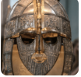 | Science  Food and the digestive system  Sound    
English
Poetry – Autumn is Here
Traditional Tale – The True Story of The Three Little Pigs
Persuasion –Christmas Dessert Social Media Post
Narrative - Marshmallows
Maths
Y3: Place Value, Addition and Subtraction and Multiplication and Division
Y4: Place Value, Addition and Subtraction Measurement and Multiplication and Division
Science and investigations
Food and the digestive system - This project teaches children about the human digestive system. They explore the main parts, starting with the mouth and teeth, identifying teeth types and their functions. They link this learning to animals' diets and construct food chains to show the flow of energy. Toothpaste investigation,

Sound - This project teaches children about sound, how sound is made and how sound travels as vibrations through a medium to the ear. They learn about pitch and volume and find out how both can be changed.
Religious Education
Emmanuel Project
– Why are good stewardship and generous giving important for every Christian?
-Why do Christians believe they are people on a mission?
Art and Design  Warm and Cool colours  This essential skills and knowledge project teaches children about colour theory by studying the colour wheel and colour mixing. It includes an exploration of warm and cool colours, Aboriginal art and how artists use colour in their artwork. | D&T  Fresh food, good food  This project teaches children about food decay and preservation. They discover key inventions in food preservation and packaging, then make examples. The children prepare, package and evaluate a healthy snack.
Computing  E-safety, Data and information – Branching databases. | Music  I’ve been to Harlem - A traditional pentatonic song about travelling around the world.
Geography  Interconnected world  This essential skills and knowledge project teaches children about compass points and four and six-figure grid references. They learn about the tropics and the countries, climates and culture of North and South America. Children identify physical features in the United Kingdom and learn about the National Rail and canal networks. They conduct an enquiry to prove a hypothesis, gathering data from maps and surveys before drawing conclusions. | Extras:  PE days – Tuesday, Friday  Useful websites  BBC Bitesize – Anglo-Saxons  British Museum – The Anglo-Saxon ship burial at Sutton Hoo  British Museum – Decoding Anglo-Saxon art  BBC Bitesize – Vikings  CBBC Newsround – What happened at the Battle of Hastings?
PSHE
Cycle safety, Healthy living, Coming home on time
French
Phonics, I’m learning French!
PE and Games
Autumn 1: Tag Rugby, Dance Autumn 2: Netball, Gymnastics

Home learning ideas
1. Imagine you are an Anglo-Saxon invader. Write a letter home to your family in Denmark, the Netherlands or Germany. Include details about the journey to England, where you have settled and explain any difficulties you have faced.
2. Use the internet to search for pictures of the artefacts found at the Sutton Hoo burial site, such as The Franks casket, purse lid and shoulder clasp. Create a piece of Anglo-Saxon art using the designs on the artefacts as inspiration.
3. Use the table below and a map of the United Kingdom to identify Anglo-Saxon place names. Explain what you think each place might have been used for or how it got its name. Visit The University of Nottingham – Key to English Place Names website to find out more about the origins of place names.
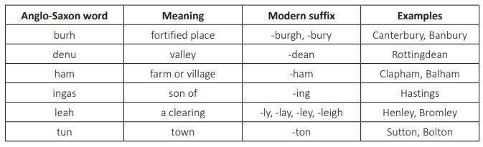
4. Use a range of historical source materials to research what everyday life was like in Anglo-Saxon or Viking Britain. Areas to research might include clothing, housing, food, culture and religion. Create a non-chronological report, blog or presentation to present your findings.
5. Imagine you are monk at Lindisfarne, who witnessed the Viking attacks on the monastery. Write a soliloquy explaining what you saw and include your thoughts and feelings about the attack. Record your soliloquy to share with the class.
6. Research a significant Anglo-Saxon or Viking figure from the list below and create a fact file or biography about your chosen individual.
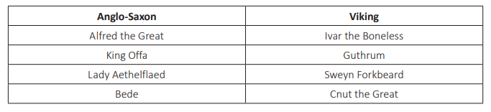 7. When Edward the Confessor died, there were three main contenders for the throne: Harold Godwinson, Harald Hardrada and William, Duke of Normandy. Research each person’s claim to the throne and write a paragraph to explain who you think was the rightful successor.
8. Use a range of resources to create a knowledge organiser about the Battle of Hastings. Include details about key dates, people and events and a paragraph to explain why this battle was so significant for England.
9. Finish your home learning by writing a summary of the topic, explaining what you have learned about invasion in the early Middle Ages.

