

St Nicholas CEVA Primary School
Station Road
Child Okeford
Blandford Forum
Dorset DT11 8EL
Tel: (01258) 860581
Fax: (01258) 863596
email: office@childokeford.dorset.sch.uk
Head teacher: Ms Jill Watson



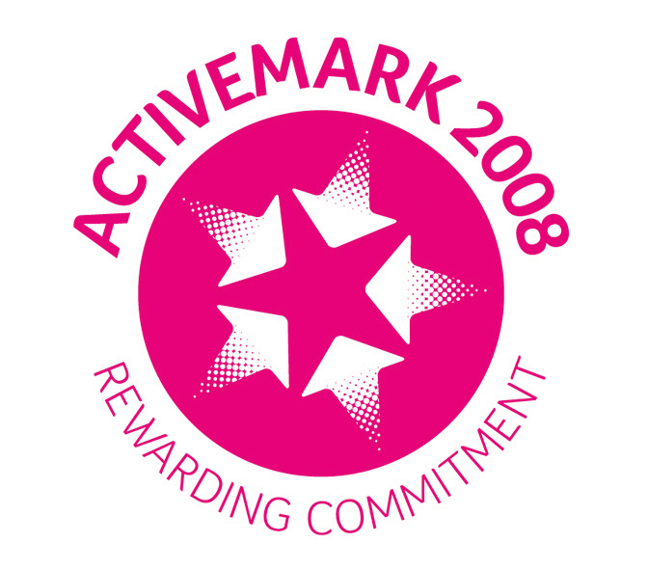


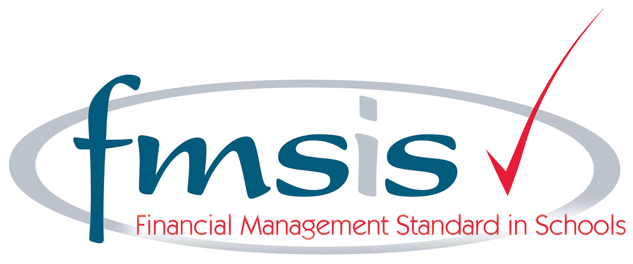
Friday 12th September 2025

Dear Parents,

Please see enclosed a ‘Sound Chart’ identifying all the initial phonic sounds your child will learn as part of our ‘Read Write Inc’ phonics programme. We will begin next week with ‘m’ (‘Maisie Mountain Mountain’) ‘a’ (round the apple, down the leaf) and ‘s’ (slither down the snake). We will learn a new sound each day. We begin with the Set 1 sounds and will move onto the Set 2 sounds after Christmas. On the school website you will find further information about our phonics programme, including lots of helpful videos to view by clicking on Students – Classes –Acorns – Read, Write, Inc Phonics (right hand side on menu).

By clicking on Students – Classes –Acorns, you will see a link on the right hand side to ‘phonics practise at home.’ I will upload on here copies of the sound sheets we do in school so that you can print these off and practise further at home if you so wish.

Please keep the laminated sound card inside your child’s book bag. We advise looking at it from time to time with your child so they can practise the sounds they’ve learnt in school and see what sounds they’re going to learn next. I suggest looking at this chart when you hear your child read.

Your child has also come home today with a library book. *Please note that these books are designed to be looked at together and adults read the story-I am not expecting your child to be able to read any of the words at this stage!!!*
I will send home phonic-specific books once we have learnt more sounds. Please ensure these books and the reading record stay inside your child’s book bag each day as they will read with an adult in school. It is recommended that you read with your child for 10 minutes daily.

If you have any questions about our phonics scheme or any other general queries relating to reading, then please do not hesitate to ask.

Regards,
Mrs Kinsey

Deffff

