
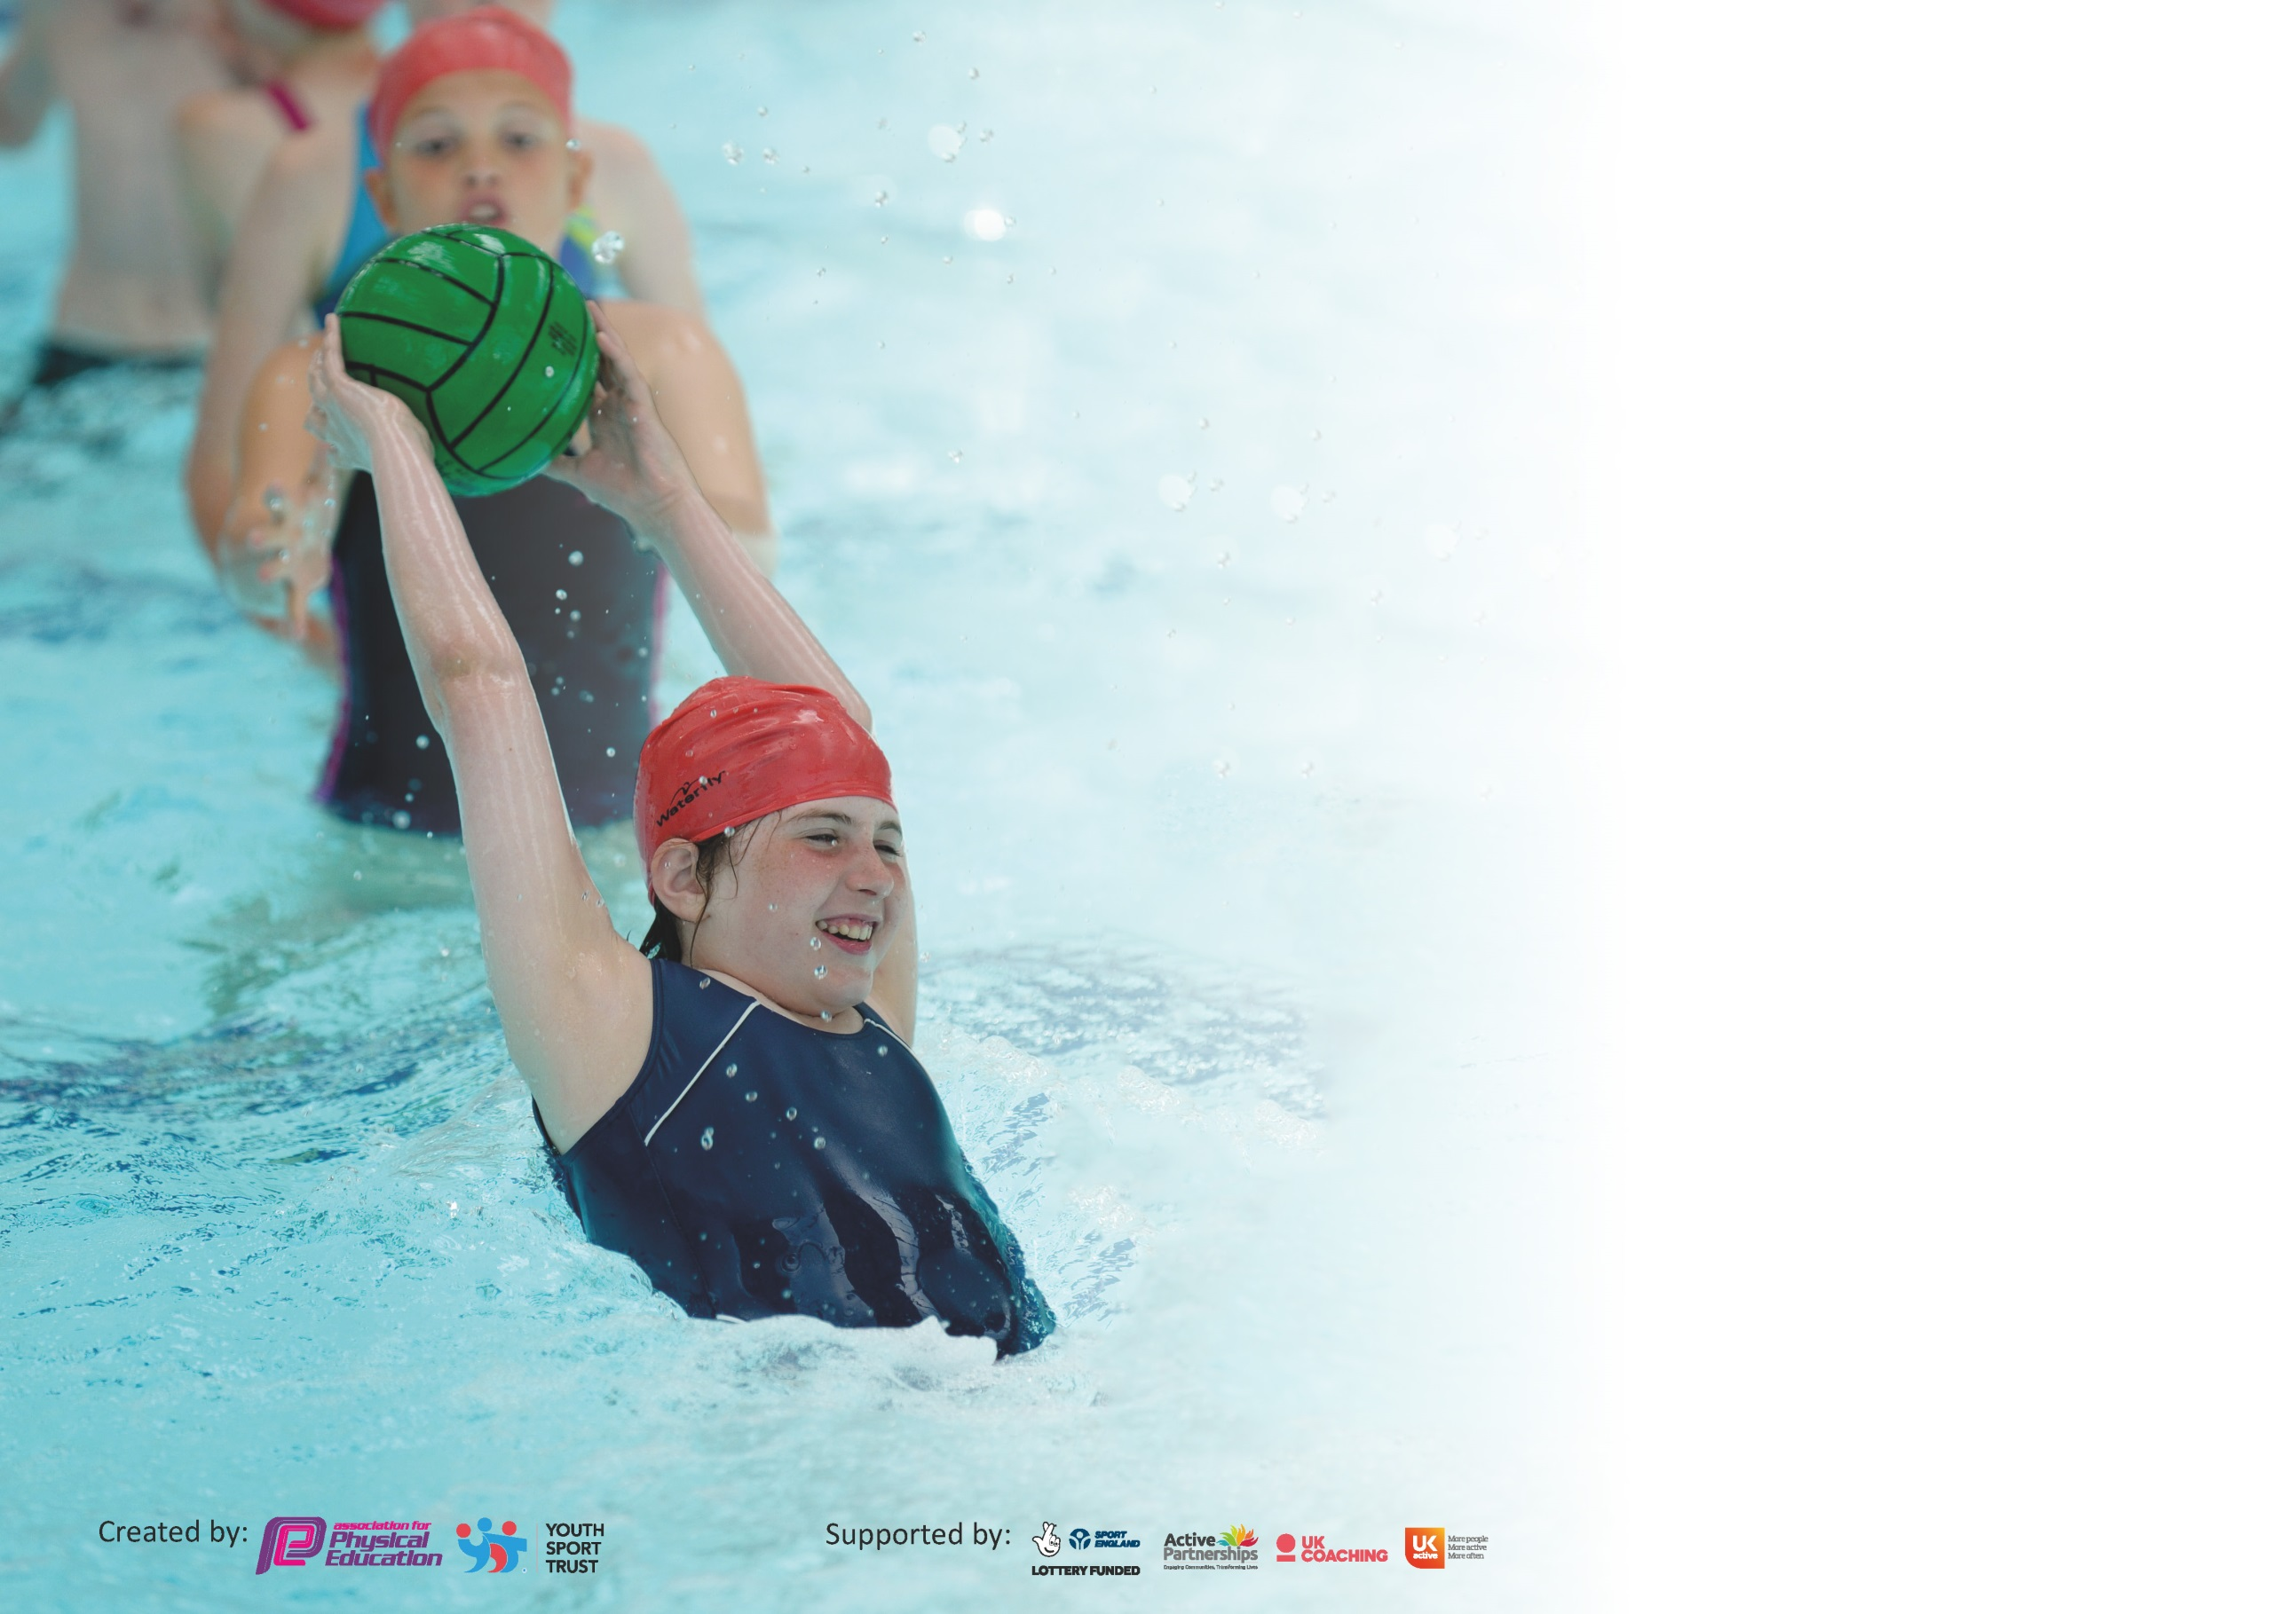

It is important that your grant is used effectively and based on school need. The Education Inspection Framework (Ofsted 2019 p64) makes clear there will be a focus on ‘whether leaders and those responsible for governors all understand their respective roles and perform these in a way that enhances the effectiveness of the school’.

Under the Quality of Education criteria (p41) inspectors consider the extent to which schools can articulate their curriculum (INTENT), construct their curriculum (IMPLEMENTATION) and demonstrate the outcomes which result (IMPACT).

To assist schools with common transferable language this template has been developed to utilise the same three headings which should make your plans easily transferable between working documents.

Schools must use the funding to make additional and sustainable improvements to the quality of Physical Education, School Sport and Physical Activity (PESSPA) they offer. This means that you should
use the Primary PE and Sport Premium to:

- Develop or add to the PESSPA activities that your school already offer
- Build capacity and capability within the school to ensure that improvements made now will benefit pupils joining the school in future years

Please visit gov.uk for the revised DfE guidance including the 5 key indicators across which schools should demonstrate an improvement. This document will help you to review your provision and to report your spend. DfE encourages schools to use this template as an effective way of meeting the reporting requirements of the Primary PE and Sport Premium.

We recommend you start by reflecting on the impact of current provision and reviewing the previous spend.

Schools are required to publish details of how they spend this funding as well as on the impact it has on pupils’ PE and sport participation and attainment by the end of the summer term or by 31st July 2020 at the latest.

We recommend regularly updating the table and publishing it on your website throughout the year. This evidences your ongoing self-evaluation of how you are using the funding to secure maximum, sustainable impact. Final copy must be posted on your website by the end of the academic year and no later than the 31st July 2020. To see an example of how to complete the table please click HERE.

Support for review and reflection - considering the 5 key indicators from DfE, what development needs are a priority for your setting and your pupils now and why? Use the space below to reflect on previous spend and key achievements and areas for development.

Key achievements to date until July 2019: | Areas for further improvement and baseline evidence of need:
- Priorities identified for next year`s CPD  - Increased participation in clubs prior to lockdown  - Use of SGO material during lockdown to engage pupils in competition  - Full participation in local competition programme prior to lock down  - Full participation in intra ( inter-house) programme prior to lockdown  - Attendance at Webinar on `Deep Dives into PE` to inform new action plan. | More active curriculum to be developed  Enrol support for curriculum development/audit support

Meeting national curriculum requirements for swimming and water safety.
What percentage of your current Year 6 cohort swim competently, confidently and proficiently over a distance of at least 25 metres?  N.B. Even though your pupils may swim in another year please report on their attainment on leaving  primary school at the end of the summer term 2020. | 69%
What percentage of your current Year 6 cohort use a range of strokes effectively [for example, front crawl, backstroke and breaststroke]? | 69%
What percentage of your current Year 6 cohort perform safe self-rescue in different water-based situations? | 96%
Schools can choose to use the Primary PE and Sport Premium to provide additional provision for swimming but this must be for activity over and above the national curriculum requirements. Have you used it in this way? | Yes

Action Plan and Budget Tracking
Capture your intended annual spend against the 5 key indicators. Clarify the success criteria and evidence of impact that you intend to measure to evaluate for pupils today and for the future.

Academic Year: 2019/20 | Total fund allocated: £17,307  Total spend £6782.31 (40%) |  |  | Date Updated: Sept 2020
Key indicator 1: The engagement of all pupils in regular physical activity – Chief Medical Officer guidelines recommend that primary school pupils undertake at least 30 minutes of physical activity a day in school |  |  |  |  |  |  | Percentage of total allocation:
 |  |  |  |  |  |  | £1003 = 6%
Intent | Implementation |  |  |  |  | Impact
Your school focus should be clear what you want the pupils to know and be able to do and about  what they need to learn and to  consolidate through practice: | Make sure your actions to achieve are linked to your intentions: |  |  | Funding allocated:  Red indicates money spent |  | Evidence of impact: what do pupils now know and what can they now do? What has changed?: | Sustainability and suggested next steps:
To train and employ sports leaders to promote participation across the school  To identify children who are not doing enough physical activity and engage them in new opportunities and raise self esteem and wellbeing  To involve children who have a low activity rate in weekly sessions (Change for Life) | Sports leaders to run lunchtime clubs  Surveys and discussions with pupils to develop a programme to increase PA .  Employ teacher to run a lunchtime club to include dog walking |  |  | £244.62 training and teacher cover costs  Teacher x 20hrs £758.38 |  | Achieved and 6 pupils trained and keen to run clubs- not established due to COVID 19. Sports Leadership has a high profile in school- many children applying for the role.  Dog walking groups running to encourage less active children at breaks and lunchtime ( on and off premises | Try again next year and use staff meetings early in the year to involve staff in designing opportunities to increase daily activity.  Continue this initiative
Key indicator 2: The profile of PESSPA being raised across the school as a tool for whole school improvement |  |  |  |  |  |  | Percentage of total allocation:
 |  |  |  |  |  |  | £1706.25= 10%
Intent | Implementation |  |  |  |  | Impact
Your school focus should be clear what you want the pupils to know and be able to do and about  what they need to learn and to  consolidate through practice: | Make sure your actions to achieve are linked to your intentions: |  |  | Funding allocated: |  | Evidence of impact: what do pupils now know and what can they now do? What has changed?: | Sustainability and suggested next steps:
To focus on mental wellbeing and related activities (see indicator 4)  To involve all staff in decision making about how to raise the profile of PESSPA  To use leaders to promote the profile of school sport  To continue to celebrate sporting achievements and promote club links through regular celebration assemblies and annual sporting awards.  To ensure that high quality equipment is available for the teaching of PESSPA throughout the school by monitoring equipment and ordering replacement resources and new exciting and inspiring equipment  To ensure that planning and implementation of all aspects of the PE curriculum are in place and delivered well | See indicator 4  Monitoring  Leaders to run intra competitions and to run lunchtime clubs  Weekly match reports and club achievements in assemblies  Regular checks of inventory to identify needs  Dedicated subject leadership time |  |  | See indicator 4  £ 2000 (allocated)  Autumn 2019  Tennis Balls £122.00  Table Tennis Net £3.16  Playground Balls £38.90  4 October 2019  Tag Rugby Bands £63.00  13 November 2019  Football Socks £37.49  (Spending : £264.55)  Balls and equipment to ensure covid safety bubble specific rotations  £626.28  1 hr per week x 20 ss £815.42 |  | COVID and staffing issues have compromised this initiative  Achieved- children proud to share achievements no matter how big or small – news is posted on PE board. Children aspire to be in teams and to share news.  Increased self esteem and ambition  Replacement balls, tag belts, goal nets etc purchased  Curriculum overhauled and fixtures reviewed | Reconsider for next year  Continue  Continue and focus on being ready for ofsted deep dive
Key indicator 3: Increased confidence, knowledge and skills of all staff in teaching PE and sport |  |  |  |  |  |  |  | Percentage of total allocation:
 |  |  |  |  |  |  |  | £819.66 = 5%
Intent |  | Implementation |  |  | Impact
Your school focus should be clear |  | Make sure your actions to | Funding |  | Evidence of impact: what do |  |  | Sustainability and suggested
what you want the pupils to know |  | achieve are linked to your | allocated: |  | pupils now know and what |  |  | next steps:
and be able to do and about |  | intentions: |  |  | can they now do? What has
what they need to learn and to |  |  |  |  | changed?:
consolidate through practice:
To identify curriculum areas for development and allocate training and resources.  To train sports leaders |  | PE leader to survey staff and monitor provision to prioritise areas where training is required and then source appropriate training and resources to address the need.  (See indicator 1) | Subject Leadership day x 2- £ 489  Training for staff.  CR- Gym course £ 75 + cover £255.66  ( see indicator 1) |  | Monitoring complete and areas identified but training not completed due to COVID. Webinar on deep dives attended.  1 member of staff attended gymnastics training and found it very useful. Resource in place and effective ( Head over Heels). To be rolled out to all staff. |  |  | Training resource for gymnastics to be rolled out to all staff in September. 8 hrs online CPD ( head over heels- £199)  EYFS training requested  Active Literacy/numeracy training requested
Key indicator 4: Broader experience of a range of sports and activities offered to all pupils |  |  |  |  |  |  |  | Percentage of total allocation:
 |  |  |  |  |  |  |  | £3253.40 = 19 %
Intent |  | Implementation |  |  | Impact
Your school focus should be clear |  | Make sure your actions to | Funding |  | Evidence of impact: what do |  |  | Sustainability and suggested
what you want the pupils to know |  | achieve are linked to your | allocated: |  | pupils now know and what |  |  | next steps:
and be able to do and about |  | intentions: |  |  | can they now do? What has
what they need to learn and to |  |  |  |  | changed?:
consolidate through practice:
Additional achievements:  Provide new opportunities for Mental Well-being:  - Introduce Forest Skills  - Yoga  - Daily mile  - Active Literacy/Numeracy  Add Basket ball to the yr 6 curriculum  To add dance club to the curriculum  To add life saving lessons to the swimming curriculum for those pupils who have achieved the core objectives  Add extra-curricular multi sports club for key stage 1  Netball club for extended age range  Rounders club  Weekly club (Rugby/Gym)  Weekly club (Athletics)  Tennis coaching |  | To employ an outside agency to deliver Forest Skills to groups as part of a rolling programme  To employ a yoga coach to deliver sessions for year 6 pupils in the lead up to SATs and transition  To ensure that classes increase opportunities for daily running by marking out a course and encouraging staff to provide opportunities for their classes to run regularly  To ask member of staff to feed back on training from active numeracy course  To employ coach to introduce basket ball as a workshop  To run a weekly dance club to be lead by a qualified dance coach 1 member staff to attend for CPD  To employ an additional teacher for the new group and subsidise travel costs  To employ external coach to run club  To employ HLTA to run sessions  To employ HLTA to run sessions  To employ qualified teacher to run club on weekly basis  To employ qualified teacher to run club on weekly basis  To employ tennis coach on weekly basis | £ 2000  £150  £ 100  £ 177.00  £ 744.74 -2 x TA cover  Transport – 10 x £60 =£ 600  £ 53.00 to subsidise costs  TA x 20 hrs £248.24  TA x 10 hrs  x 20 hrs =£815.42  x 10 hrs  Coach x 10 hrs £365  Local Tennis club coach subsidy £250 |  | Not achieved- staffing  Not achieved – Covid 19  Some success with this. Yr 5/6 class ran at least twice a week on top of 2 hr curriculum PE and also had `active breaks` where children choose from a range of activities for extra break.  Not achieved  Sessions ran in yr 5/6 class but not the workshop session. Pupils really enjoyed the lessons.  Weekly sessions in place for key st 1 and key st 2. Good level of attendance .  Weekly videos also developed during lockdown for home learning  Sessions ran for yr 4/5 .  Sessions for yr 3 cancelled due to COVID  Sessions well attended and ran regularly through Autumn and Spring term  Sessions ran regularly with increasing numbers  COVID  Sessions ran at full capacity  COVID  COVID |  |  | Well being for staff – ideas to be discussed  Try again next year  Increase focus here  Plan a date for feedback in staff meeting  Book coach in for Spring term when COVID restrictions may be more relaxed  Continue sessions

Key indicator 5: Increased participation in competitive sport |  |  |  | Percentage of total allocation:
 |  |  |  | %
Intent | Implementation |  | Impact
Your school focus should be clear | Make sure your actions to | Funding | Evidence of impact: what do | Sustainability and suggested
what you want the pupils to know | achieve are linked to your | allocated: | pupils now know and what | next steps:
and be able to do and about | intentions: |  | can they now do? What has
what they need to learn and to |  |  | changed?:
consolidate through practice:
Regular programme of intra- events for all children in key stage 2  At least 2 events for key stage 1  Area/district and county events for yr grps 2-6 | Fixture lists compiled with local schools and Sch Games Co-ordinator.  Events lead by staff | £ 1000 for transport and supply cover to enable teams to compete | Winter programme completed but COVID 19 affected. Football, Netball, Orienteering, TAG rugby,  Spring/Summer programme. | Next year`s programme has been adapted to start later in the year to accommodate continuing COVID restrictions  Increase intra opportunities to compensate for lack of inter events

Signed off by
Head Teacher: | Jill Watson
Date: | 16/11/20
Subject Leader: | Sarah Salisbury
Date:
Governor: | Lynne Crighton
Date: | 23/11/20

