
Home log-in

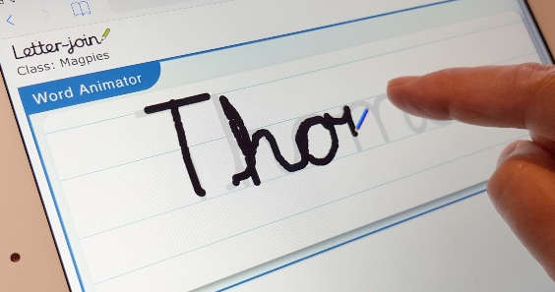
Dear Parents,
Our school is now part of the Letter-join handwriting scheme and our pupils can log in to the Letter-join website on iPads and tablets as well as desktop and laptop computers at home.
There you will find the same, easy-to-use handwriting resources that we use at school.

PC DESKTOP AND LAPTOP LOG-IN
Log in at www.letterjoin.co.uk and use the
Desktop log-in option with these details:
User name: eg6209
Password: home

PC Browsers:
Letter-join will work on the following browsers on PCs/Macs:
• Google Chrome
• Firefox
• Safari
Do not use Internet Explorer.

IPAD AND TABLET LOG-IN
Go to www.letter-join.co.uk and use the Tablet log-in option with these details:
User name: eg6209

Swipe code
(starting at top left):

Tablet/iPad Browsers:
Letter-join will run on the following tablets:
• iPads running iOS7 and above through the Safari browser.
• Windows 8 tablets (8 inch and bigger) using the built-in browser.
• Android tablets (8 inch and bigger) using Google Chrome, Firefox or Opera.

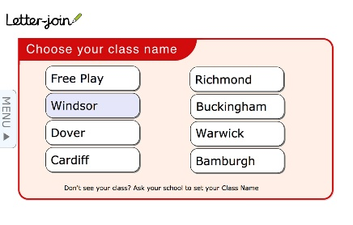
Choose a Classroom
Once logged-in, choose your child’s classroom and you can use Letter-join’s resources and fun activities to reinforce the handwriting we teach at school. You can trace over the letters and words and play the games on your tablet.
We are limited to the number of users who can log in to this account, so please do not share these log-in details.

