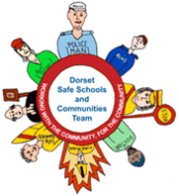
Parents’ E-safety Information
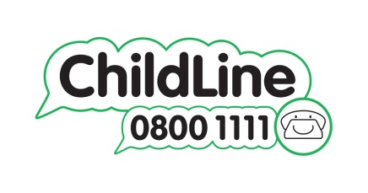 | Childline  Private and confidential service for children and young people up to the age of nineteen to find advice and discuss issues with counsellors.  www.childline.org.uk/  Tel: 0800 1111
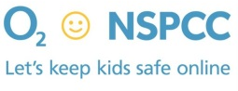 | NSPCC/O₂ Parents E-safety Helpline  Free service to give advice to parents Tel: 0808 8005002
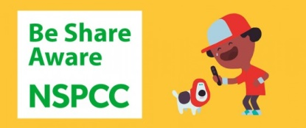 | NSPCC Share Aware  Advice for parents particularly aimed at those with children aged 8-12 years old.  http://www.nspcc.org.uk/preventing-abuse/keeping-children-safe/share-aware/
Child Exploitation and Online Protection (CEOP) Centre
Advice on internet safety for young people, parents and professionals
Report inappropriate website content or contact with a young person
www.ceop.police.uk/

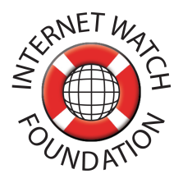 | Internet Watch Foundation  UK Hotline for reporting criminal content including child abuse content so that it can be removed.  www.iwf.org.uk
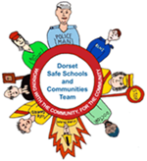 | Safe Schools and Communities Team (Dorset)  Advice and links about different issues relating to young people including internet safety  http://www.dorset.police.uk/default.aspx?page=3638
ThinkUKnow
Advice on internet safety for young people, parents and professionals
www.thinkuknow.co.uk

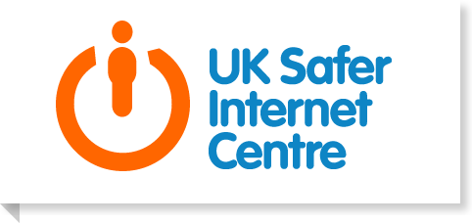 | UK Safer Internet Centre  Advice on internet safety for young people, parents and professionals.  Go to Advice and Resources – Parents and Carers section for information on parental controls for home internet, parental controls on devices and privacy settings on social networks.  www.saferinternet.org.uk/

Parents’ E-safety Tips

