
SUMMARY OF SCHOOL DEVELOPMENT PLAN PRIORITIES 2015-2016

Vision Statement
‘At St Nicholas we nurture everyone to be the best we can be, in a caring and inclusive Christian environment.’


ACHIEVEMENT AND STANDARDS

- Raise standards in Maths across the school
- Raise boys achievement particularly in writing and reading
- Continue to raise standards in spelling and phonics

TEACHING & LEARNING & ASSESSMENT

- Planning fewer things in greater depth so the children deepen and broaden their understanding of key skills and concepts.
- Provide effective feedback so the children are clear about what they are learning, what they are doing well and what they need to do to improve.
- Developing the pupils ability to reflect on their own learning and plan for improvement (ASSESSMENT FOR LEARNING – AFL)
LEADERSHIP & MANAGEMENT

- To embed the New Curriculum and increase the whole community’s understanding of age related expectations and the role they can play in supporting the children’s learning.
- Ensuring all leaders (at all levels) have accurate picture of the schools current strengths, areas of development and a clear understanding of the steps being taken to maintain and improve the quality of our provision
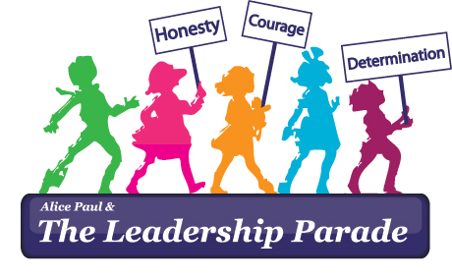
- To maintain and strengthen the distinctiveness of our church school

Behaviour and Well being

- Development of family groups and buddy systems
- Increase pupils understanding of how to stay safe, particularly on the internet and mobile devices.
- Further increase pupils responsibility for their own learning and behaviour

